Whiskers and Soda, a cat café in East Dallas, celebrated its first anniversary this week, marking a year of success in boosting cat adoption rates, spreading awareness, and providing furry friends with forever homes in the Texas community.

### Since its opening in March 2023, Whiskers and Soda has become renowned for its welcoming and interactive atmosphere. While being a home to adoptable cats, the cafe sets itself apart from a typical adoption center and coffee shop.

“Our space is designed to be as much about the human experience as it is about the cats. It's a place where you can unwind, enjoy a cup of coffee, and potentially meet your new best friend,” said Caroline Stovall, co-owner of Whiskers and Soda. The environment is intended to encourage natural interactions with the cats, while also creating a more enjoyable experience for the visitors.

### Juliana Judge, a visitor and recent adopter, who lives down the street from the cafe, shared her experience during her visits.

### “It’s more like visiting a close friend’s home than your typical adoption center like a PetSmart or something. You’re also surrounded by people that love the same thing as you, cats, which is amazing because it feels a bit more authentic. It’s not just someone trying to make money or push you to make a decision,” said Judge.

Juliana frequently visited the café with friends before adopting Luna, a 4-month-old kitten.

“Luna, who I hadn’t seen there before, immediately jumped over to me and sat on my lap. It felt like she was choosing me. Of course I had to choose her too. It actually was love at first sight.”

After this initial connection, Luna and her new owner quickly became inseparable. Today, they still share a close bond as they live together in Juliana’s townhome.

“Watching her sunbathe in my window sills and wait for me to get home every day really makes me feel like I have a true bestie. I can’t imagine my life without her,” Judge said, reflecting on her special bond with Luna.

### The cafe, Owned by Caroline and Rob Stovall, teamed up with A Voice for All Paws, a local cat rescue organization, to make the café possible.

### “We partner with A Voice For All Paws which is a rescue that I’m actually the president of. The major reason that we set up the cat café was to help with the number of adoptions," said Stovall.

### 

### Whiskers and Soda has significantly increased awareness of nonprofit, A Voice for All Paws, and together they have found homes for nearly 3,000 kitties and cats.

### “So far in 2024, we have helped facilitate around 2,100 adoptions and fosters, which is definitely more than our numbers from last year. Most of them [cats] are from the streets, owner surrenders or shelters across Texas. Right now, we have around 400 in our care,” said Jen, an associate at A Voice for All Paws.

### In 2023, the rescue and cafe recorded a total of 628 adoptions while working together. Having already surpassed that number by a significant margin in 2024, with several months still remaining, Whiskers and Soda has hit a major milestone.

Located at 10320 Garland Road in Dallas, Whiskers and Soda operates as a membership-based café. However, non-members are able and encouraged to visit. For walk-in visits, the rates are $16 per hour for adults and $8 per hour for children.

Lexi Pardonson, a staff member at the cafe, shared one of her most touching memories during her employment at the cafe the past year.

“Honey was a super timid, older and kind of grouchy tabby [cat] that had been with us for like nine or ten months. She was given to us because her previous owner had abused and abandoned her. All of us were scared she was being overlooked because of her age and sassiness, not knowing what her previous life was like. One day, an older woman came in for her first time. After ordering a coffee and looking around, she met Honey and sat with her for two or three hours. She ended up adopting her that day. Watching them together and seeing both of their eyes light up was really touching. I think Honey knew she was meeting her new mom, and vise-versa. Just pure joy, yeah that was adorable.”

During Stovall’s process of creating Whiskers and Soda, she said, “We tried to come up with a Four Seasons for cats. Us as cat owners, found it very very difficult to board our cats because we were always so uninspired by the options that were available, with you know next to dogs in metal cages or next to animals that are sick so we wanted a safe, secure, gorgeous location that you can board your cat. And I think we’ve come up with that.”

Stovall's commitment to providing a luxurious and safe space for cats has clearly made its mark in helping the Dallas community.

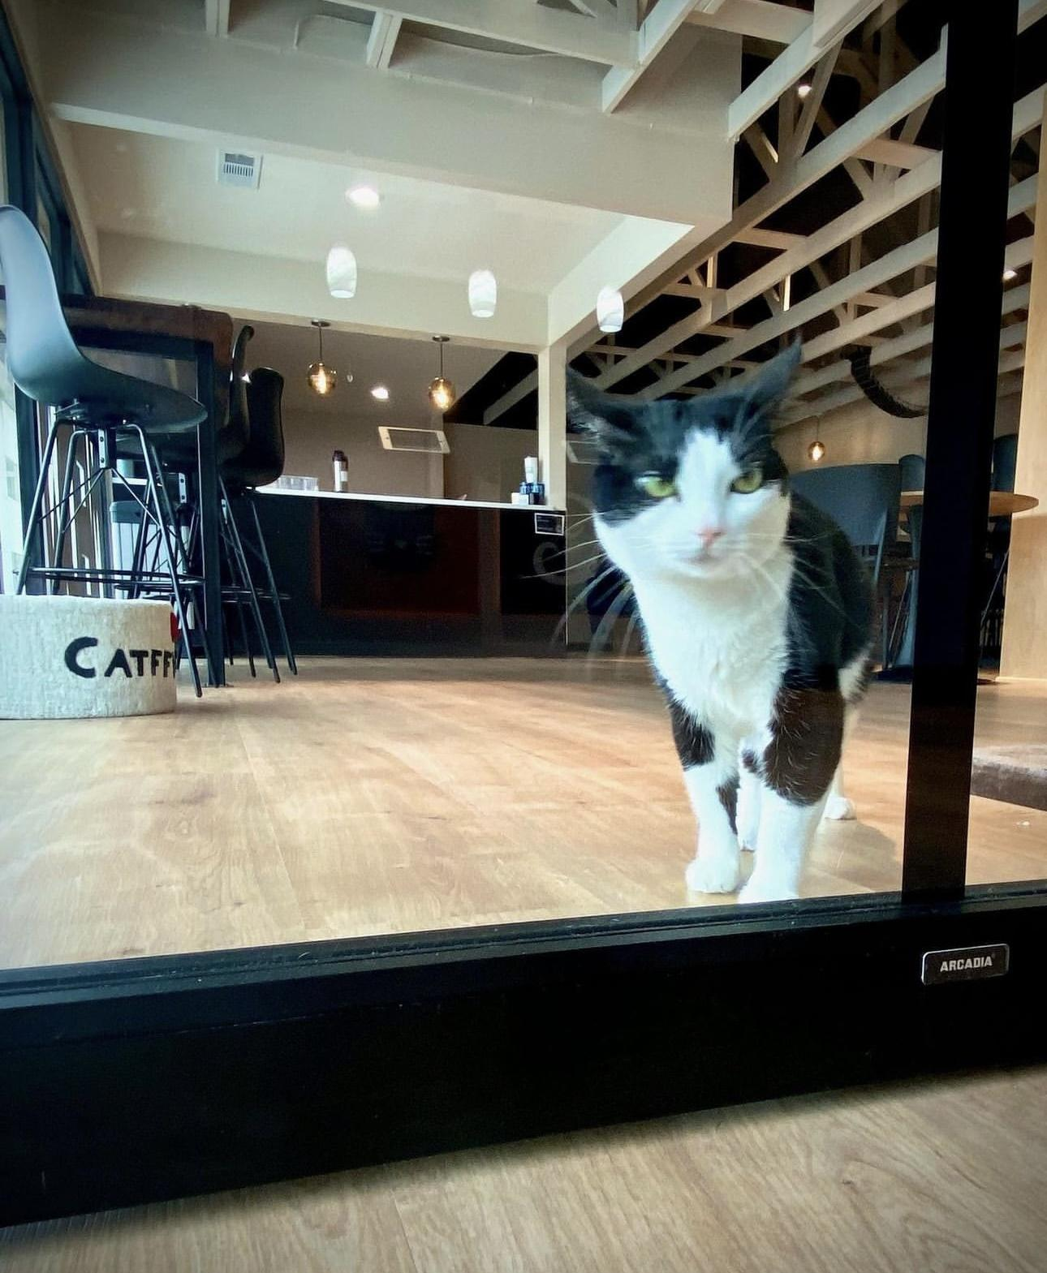

Panda Bear greets guests at the café’s entrance window. (Photo by Turley)

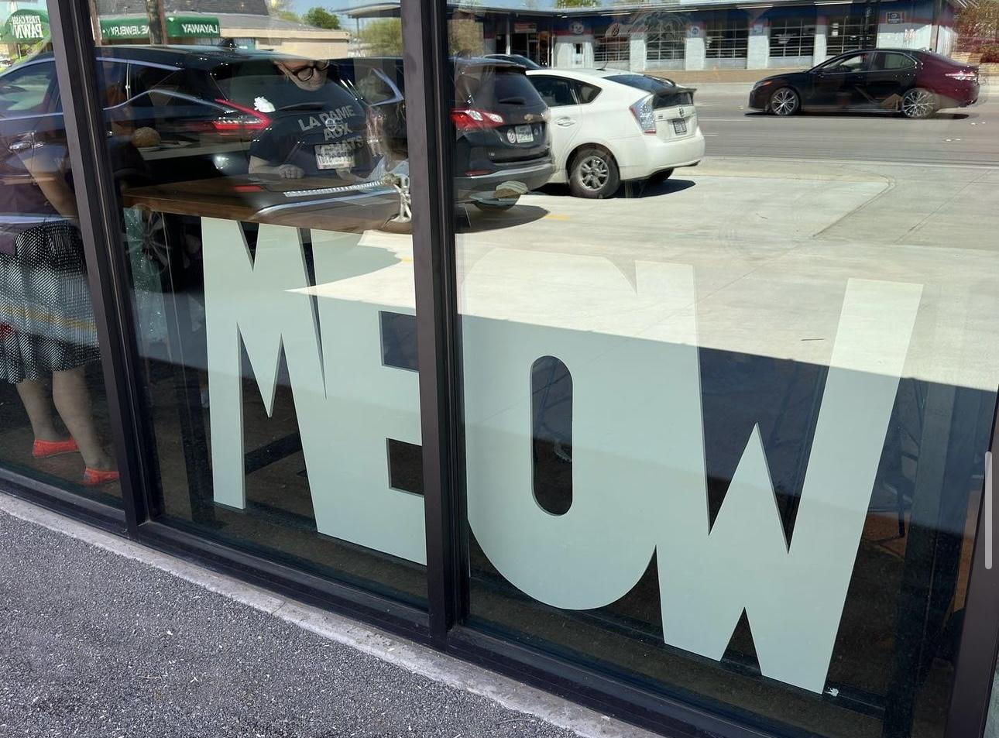

The windows that greet people walking by and/or visiting Whiskers and Soda. (Photo by Turley)

### Interview Sources:

### Caroline Stovall, co-owner of Whiskers and Soda, president of A Voice For All Paws.

(214) 233-6176

### Juliana Judge, Whiskers and Soda cat adopter/visitor.

### (901) 607-1889

Lexi Pardonson, Whiskers and Soda staff member

(214) 233-6176