Sisters with Synths: Kenzi and Molly Porter

By CeCe Turley

Facing a crowded nightclub in New York, Kenzi Scott Porter’s fingertips pull down the slider to match the beats per minute. Her focus and passion for music is evident as she adjusts the settings, her body simultaneously moving with the music. Beside her, her sister, Molly Porter, switches the bass from the prior song to the next, twisting specific knobs that fade the tunes together. Illuminated by the glow of their equipment and the ray of changing colors from the club's ceiling lights, the sisters' pulsating beats and dynamic presence engulf the room. The lively atmosphere, vividly captured in a video shared by Molly, demonstrates the value of the sisters’ performative abilitities, song choices, and passion they bring behind the DJ booth. 

During the majority of their set, Kenzi and Molly, known as 'Sisters with Synths,' move in synchrony, making their connection with each other and the music clearly evident. The recording shows the audience that is engaged and eager to dance, is guided by the rhythm and set of songs that the sisters meticulously craft. Aware of the potential impact their decisions can have on the attendees’ moods and movements, the sister’s remain confident and unaffected by anything other than the music playing through their headphones. Showing no signs of pressure or nerves, the sisters raise their arms, spin each other around, and let their hair flow freely in the colorful rays, creating a captivating visual display. Their performance is not only a showcase of technical skill but also a reflection of their love for electronic dance music and the communities involved. As the set progresses, Kenzi glances at Molly and smiles, a silent communication that speaks volumes about their shared passion.

In September 2023, the sisters attended their first rave together, sparking much of their inspiration regarding electronic dance music and their journey of becoming a part-time DJ’s.

"We were just two sisters attending our first rave together. Kenzi actually predicted we'd be hooked, and she was absolutely right,” Molly said. “The energy of the music and the incredible people we were surrounded by really ignited our passion."

Molly and Kenzi's passion for music and DJing has grown stronger since they first started in October, as it is often in sync with their initial weekend preferences, the chance to socialize, have a drink, and enjoy the party alongside the attendees.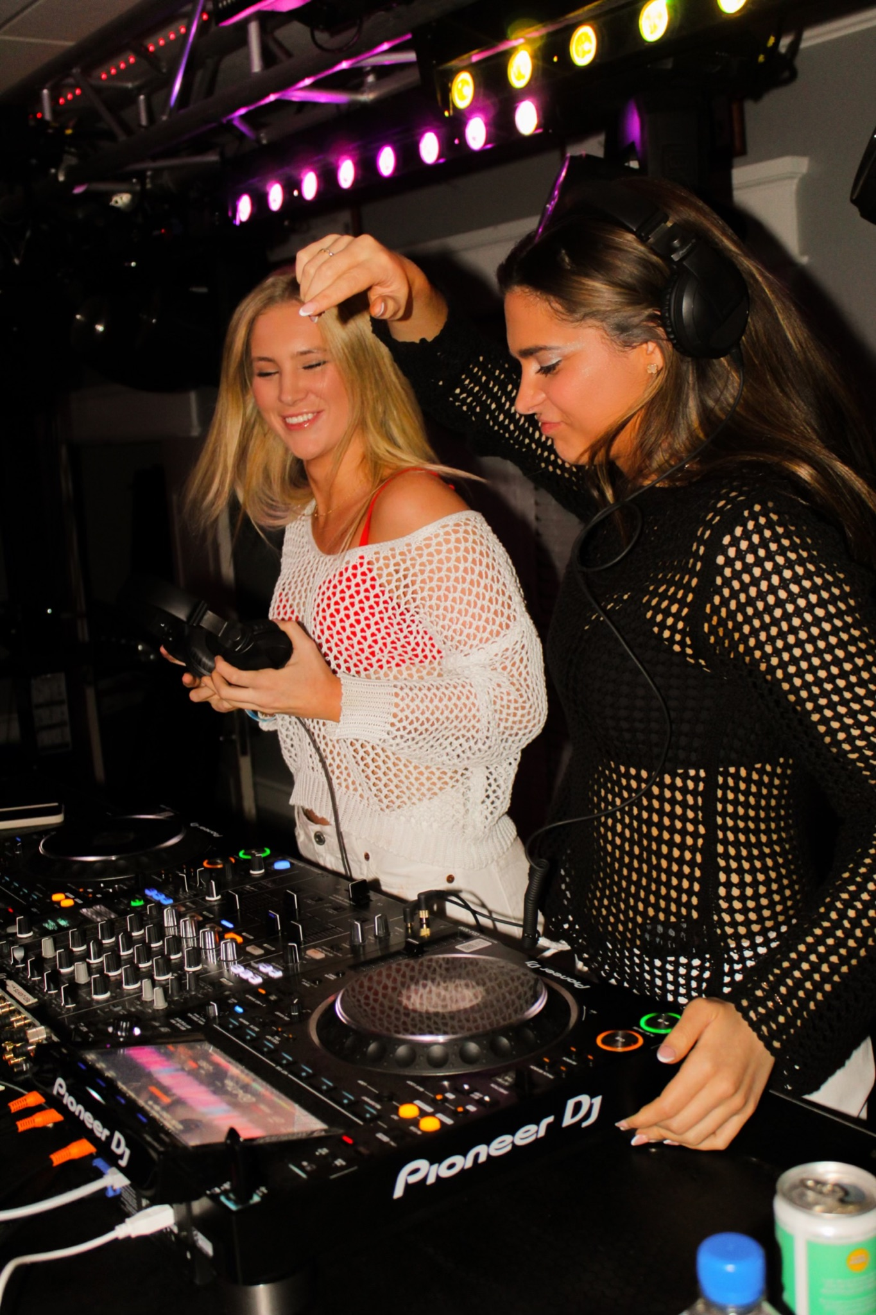

“I would probably say that getting to meet people, making relationships, and just enjoying the party aspect is what I love most about it all. Getting to DJ as a way of doing that, while also building relationships and sort of networking makes it really fun for us," said Molly.

Oftentimes, the sisters find themselves encouraged to continue booking their nightlife duties from the enthusiastic reactions and affection from the attendees.

"We thrive on the energy of the crowd," Kenzi says. "Seeing everyone lose themselves in the moment and music really makes all the hard work worth it."

Megan Underwood, a close friend of Molly’s who lives in Dallas and has attended several of their sets, shares her admiration for the duo.

“Both Molly and Kenzi have very fun and outgoing personalities, so it’s easy for them to feed off of each other’s energy in and outside the DJ booth. Obviously, their energies are amped up during a set, but I’d say it doesn’t stray far from their everyday aura,” Underwood said.

Underwood also highlights how their music easily pleases the crowd.

“I love watching them DJ. They do a mix of popular songs that everyone knows. They blend the fan favorite nostalgics [songs] while also incorporating EDM.”

With nearly a year of DJ experience, the 'Sisters with Synths' shared that they haven't faced any major setbacks but have encountered reminders and insight as female DJs in the clubbing and music industry.

“There’s such a need for more females in the space, so we on our social media always try to interview and connect with female DJs,” Molly says.

“We occasionally have had some sketchy opportunities where you know they want you to be there because you're an attractive girl, but it comes down to, is that backstage worth it? Is it worth building a relationship with a business or group where maybe their intentions are not great? For us, it’s usually not,” Molly says.

Despite their experience with occasional obstacles and necessary thoughts when booking sets, the duo continues in focusing on their music and their efforts to support fellow females.

Their involvement in the music world extends beyond their roles as DJs, contributing to female communities and music industry a bit more, digitally. With a co-run instagram account, with nearly 12,000 followers, and a well-kept website, the sisters offer behind-the-deck interviews with well-known female DJs, music festival reviews, and personalized merchandise. With an Instagram bio stating, “Your boyfriend's favorite DJ duo,” and selling personalized t-shirts and hoodies cleverly inscribed with the words, “He said me or techno. Sometimes I miss him,” the sisters manage everything from their social media accounts to their brand personalities.

The Porter sisters have made a significant mark on the community, both in and out of the DJ booth. Born in San Antonio (Molly) and Dallas (Kenzi), they both moved to New Jersey before returning to Dallas in 2011. This Fall, Molly is continuing her studies at the Fashion Institute of Technology (FIT) in New York. Now, she lives with her sister Kenzi, who also moved to New York after recently graduating from the University of Miami. Beyond DJing on weekends, Molly works as a social media marketing intern for a luxury travel agency and Kenzi has been recently hired for a public relations job in New York. 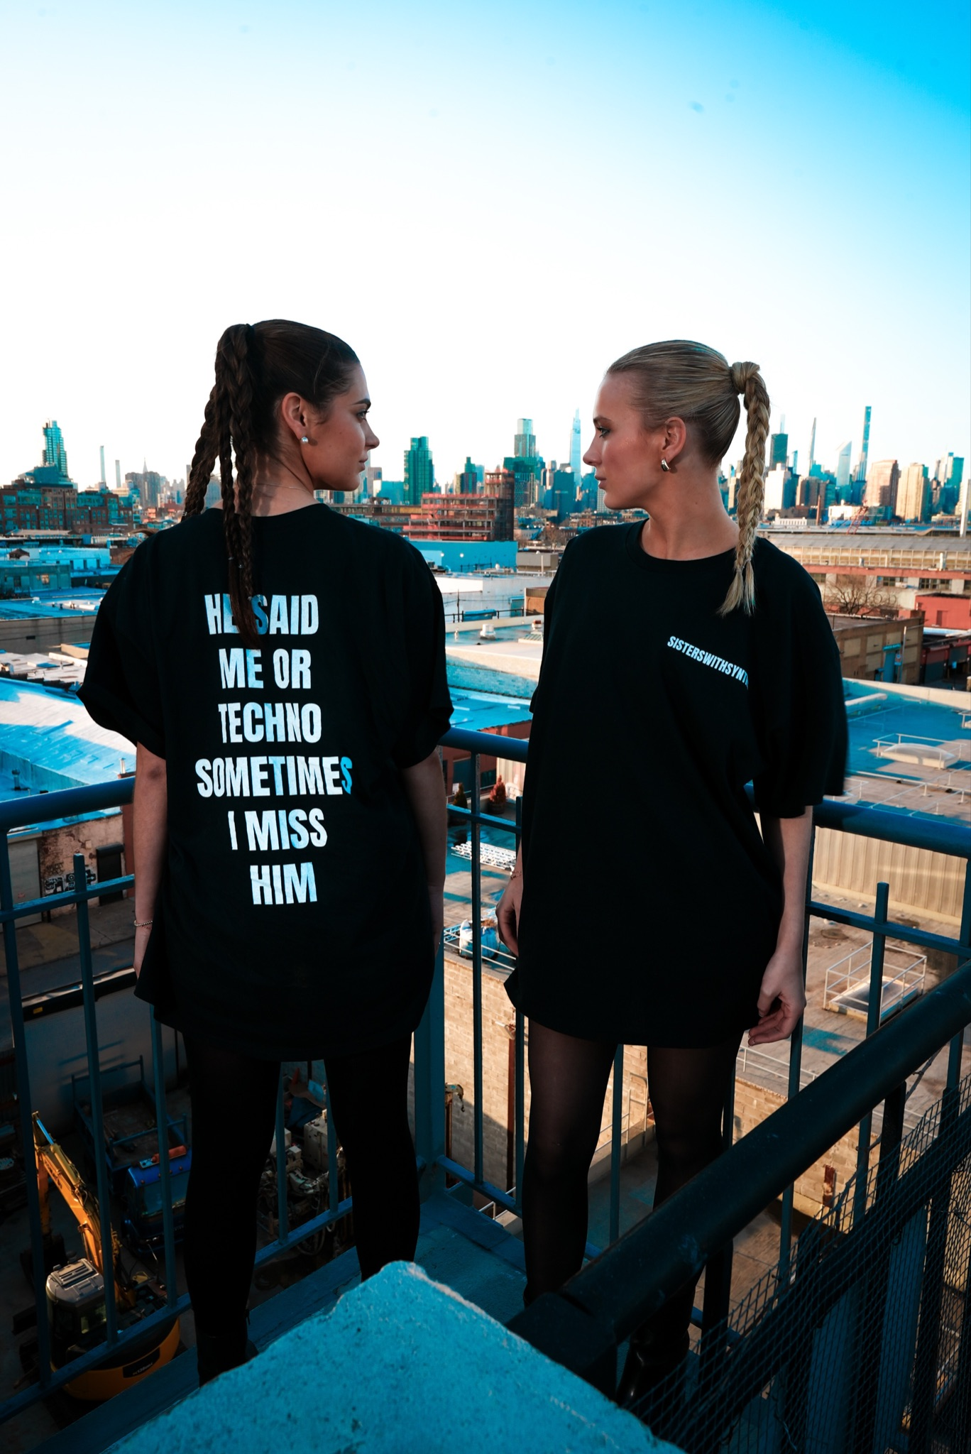

Looking ahead, the sisters have upcoming events in Dallas penciled into their calendar.

“We’re rarely both in Dallas at the same time, so we are trying to book a gig soon,” Molly says.

As summer wraps up, they’re also concluding their rooftop parties in New York, preparing for new venues and experiences. With their notable passion, dedication, and uniqueness, Kenzi and Molly, ‘Sisters with Synths’, are set to continue making waves in the music world, inspiring fellow female DJs and captivating audiences wherever they go.



Sources:

Molly Porter - (210) 330-0327

Kenzi Scott Porter - (469) 516-7711

Megan Underwood - (214) 449-2312



Cutline/Photo 1:



Cutline/Photo 2:



Cutline/Photo 3: